실습 5 - <https://d2iwdqgro8i2ew.cloudfront.net/lesson/script/53006-1.html>

실습 6

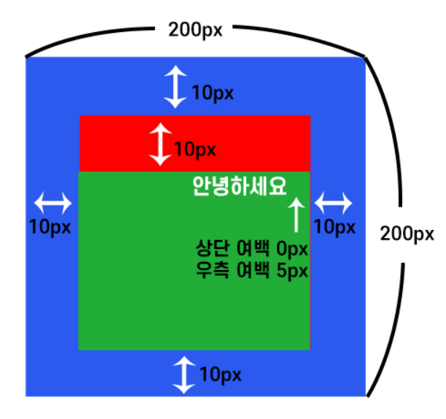

실습7

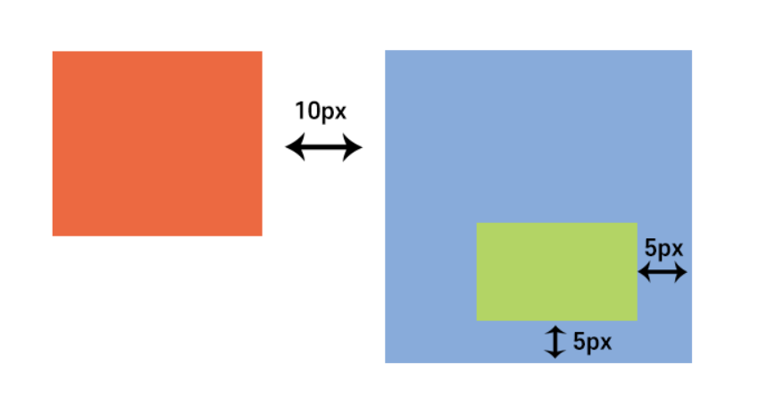

실습8

